**User Research Scoresheet**

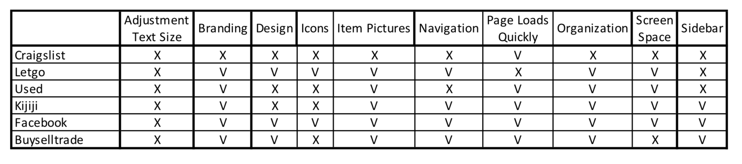

**Low-fidelity Prototypes**

Mobile Version



Tablet Version

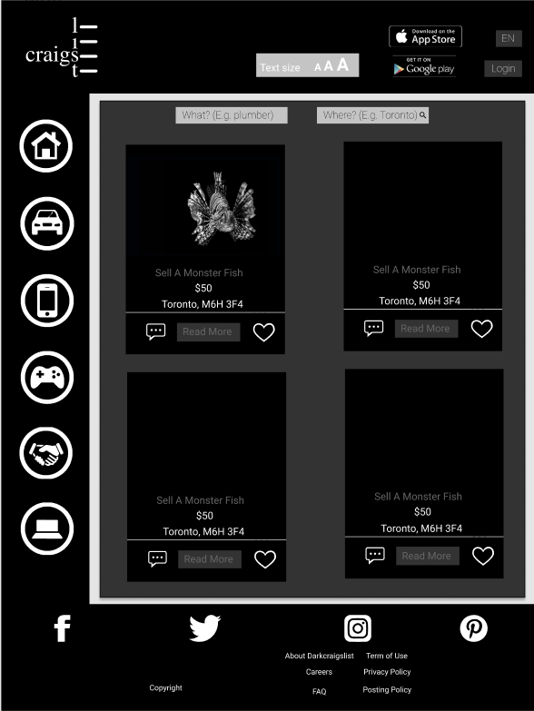

Desktop Version

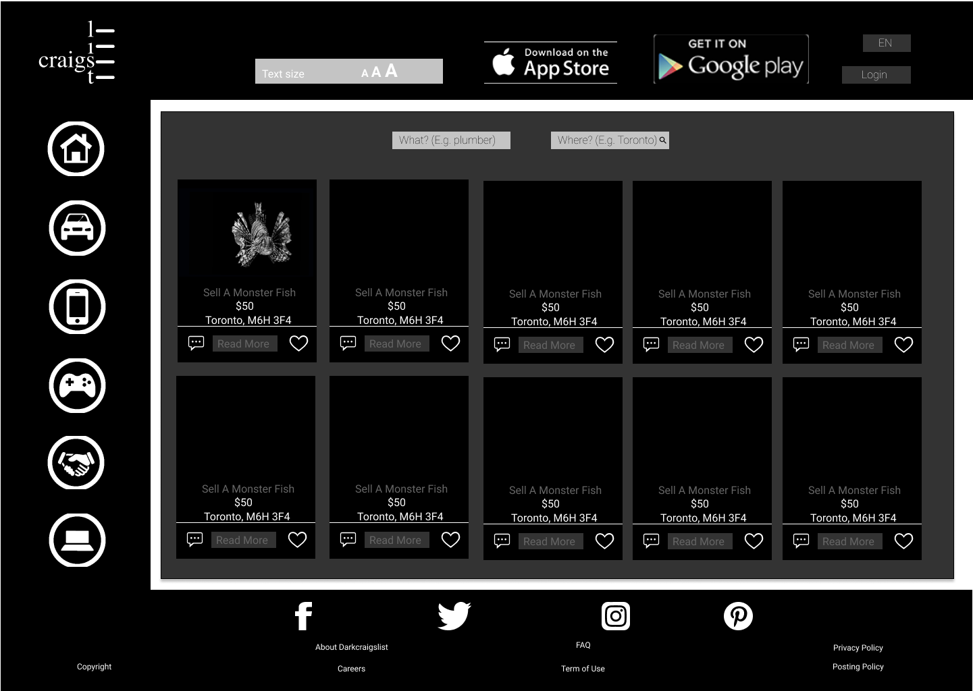

**Architecture**

<https://www.gloomaps.com/mhZnZ3MH3X>

